Forest School News: June 18
This summer term year 1 have been learning about plants and the different ways in which they can be used. We went on a plant hunt in Furzefield Wood and found plants that can be eaten, used as medicines and used to help us make fire. We did not eat any of the plants but we did try some elderflower cordial that Miss Roberts had made.
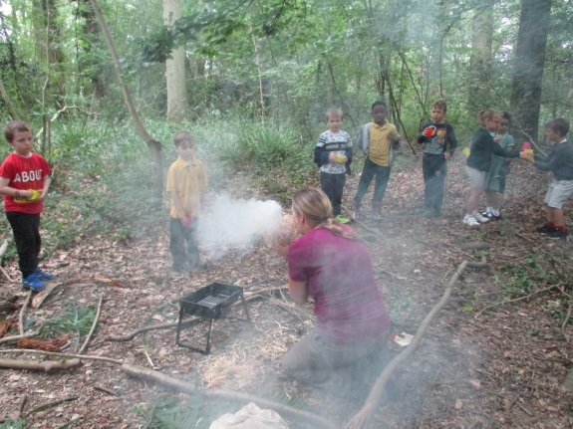
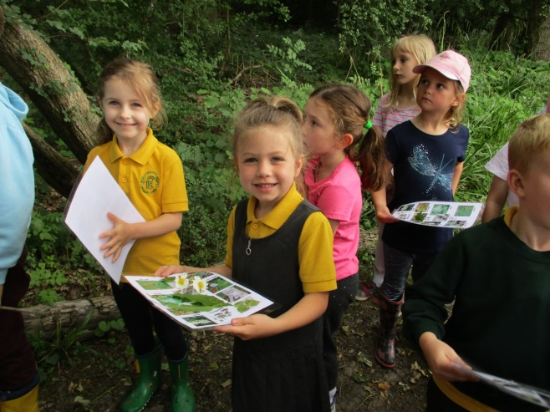

Using honeysuckle bark and cramp ball fungus to make fire.
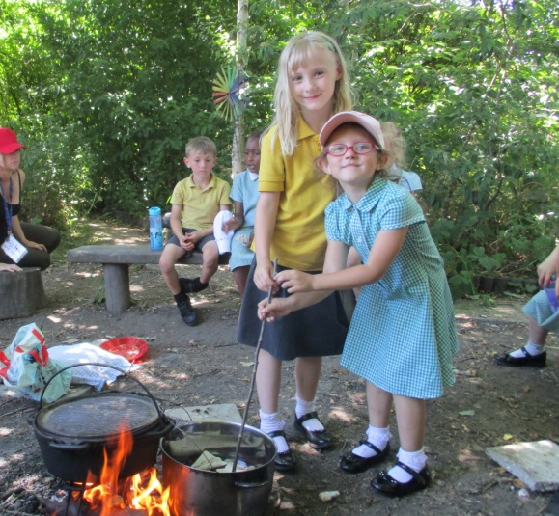
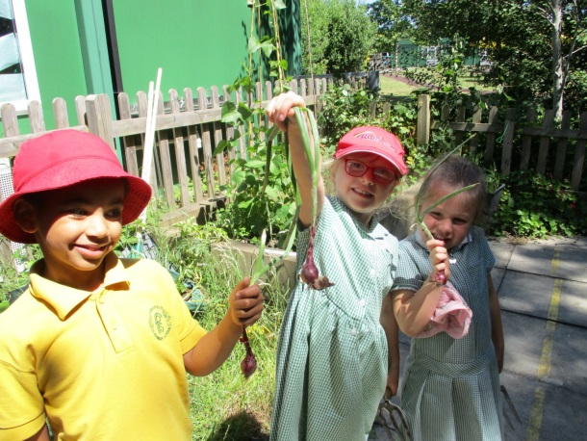
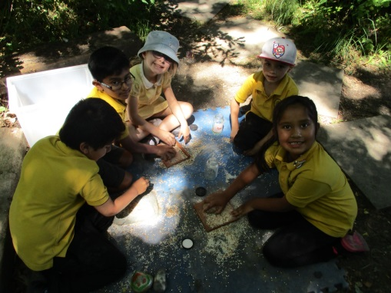

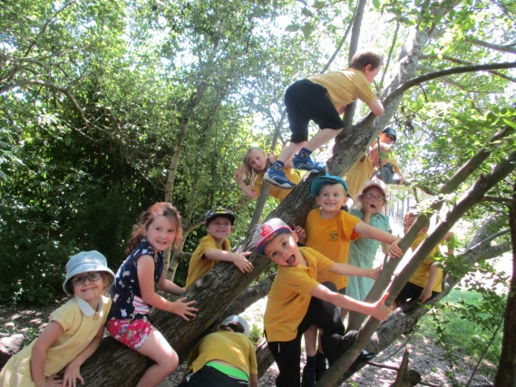
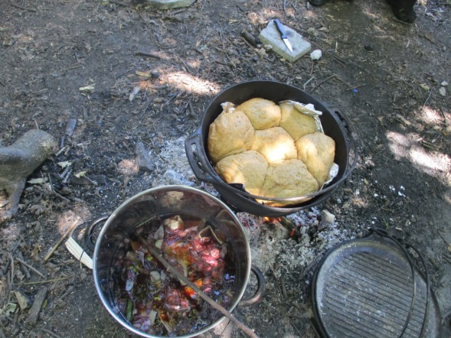

We used onion skins and madder root to dye fabrics and had a go at grinding grains before baking some bread over the camp fire.

