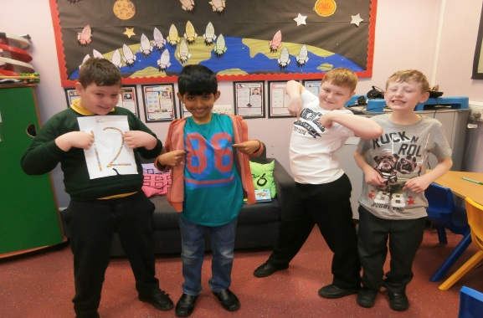
Extra-Curricular Clubs at Furzefield

BEFORE SCHOOL

Club | Who | Where | When | Years
Breakfast Club  (Fee payable) | Mrs Betts,  Miss Triance,  Miss Henty, Miss Plampton | Hall | Every Day | ALL
Athletics/Multi  Skills | Miss Schofield | Field | Tuesday | Yr 3 & 4
Athletics/Multi  Skills | Miss Schofield | Field | Thursday | Yr 5 & 6

LUNCHTIME CLUBS

DAY | CLUB | WHO | WHERE | YEARS
Monday | Book Club | Miss Hornsby | Library | Yr 6
Tuesday | Football | Coach, Miss Kothe | Field | Yr 1
Wednesday | Football | Miss Schofield | Field | Yr 2
 | Running/Multi Sports | Mrs Muggeridge, Mrs Hodges, Mrs Hamson, Miss Schofield | Field | KS2
 | Library Club | Miss Hornsby | Library | ALL
Thursday

Friday | Running/Multi Sports | Mrs Hodges, Mrs Hamson, Miss Schofield | Field | KS2

Extra-Curricular Clubs at Furzefield

AFTER SCHOOL
 | CLUB | WHO | WHERE | YEARS
MONDAY | Choir | Miss Kothe, Miss Ryan  Mrs Barber, Mrs Powell | Germany Class | KS2
 | Gymnastics | Mrs Williams, Mrs Leaver | Hall | KS2
 | Dance Club | Miss Triance, Mrs Young,  Mrs Betts | Hall | KS1
 | Homework Club | Mrs Newbury, Mrs Evans, Miss Hornsby, Mrs Dunn, Mrs Grogan | Group room & classes | Year 6
TUESDAY | Boys Football | Mr Gellett, Mrs Gouveia, Mr Cates | Field | Years 4,5,6
 | Girls Football | Mrs Burch | Field | Years 4,5,6
 | Homework Club | Mrs Newbury, Mrs Evans, Mrs Dunn, Mrs Grogan, | Group room & classes | Year 5
WEDNESDAY | Homework Club | Mrs Newbury, Mrs Evans, Mrs Grogan, Mrs Dunn | Group room & classes | Year 3
 | Dance | Miss Triance, Mrs Young,  Mrs Betts | Hall | KS2
 | Cross Country | TBC
THURSDAY | Hockey | Mr Cates, Miss Walker, Miss Hatton | Playground
 | Netball | Mrs Muggeridge, Mrs Orchard, Mrs Maiden, Miss Schofield | Playground
 | Skills School  Football | External provider | Field | Years R,1,2,3,4
 | Homework Club | Mrs Newbury, Mrs Evans, Mrs Grogan, Mrs Dunn | Group room & classes | Year 4
FRIDAY | Football | External provider | Field | KS2
 | Fitness Friday | Mr Cates, Mr Wigley, Miss Murphy, Miss Schofield, Miss Kothe | Hall | Years  4,5,6

There is an After School Club (Fun Club) bookable by prior arrangement and subject to availability (fees payable). Please contact the school for more information.

