A guide to schools for updating their SEN policies
September 2014

SPECIAL EDUCATIONAL NEEDS
AND DISABILITY
POLICY

STATUTORY

OWNER: Inclusion Manager
GOVERNOR’S COMMITTEE: Curriculum & Self Evaluation
DATE OF LAST REVIEW: Autumn Term 2020
NEXT REVIEW DATE: Autumn Term 2021

Vision Statement

Here at Furzefield School, our children develop their own self-worth in a climate of trust and happiness. Everyone is challenged to recognise and reach their full potential in order to become confident and valuable members of the local and global community.

Definition of SEN

At our school we use the definition for SEN and for disability from the SEND Code of Practice (2014).

This states:

SEN: A child or young person has special educational needs if he or she has a learning difficulty or disability which calls for special educational provision to be made for him or her. A learning difficulty or disability is a significantly greater difficulty in learning than the majority of others of the same age. Special educational provision means educational or training provision that is additional to, or different from, that made generally for others of the same age in a mainstream setting in England
Disability: Many children and young people who have SEN may have a disability under the Equality Act 2010 – that is ‘…a physical or mental impairment which has a long-term and substantial adverse effect on their ability to carry out normal day-to-day activities’.

This definition provides a relatively low threshold and includes more children than many realise: ‘long-term’ is defined as ‘a year or more’ and ‘substantial’ is defined as ‘more than minor or trivial’. This definition includes sensory impairments such as those affecting sight or hearing, and long-term health conditions such as asthma, diabetes, epilepsy, and cancer. Children and young people with such conditions do not necessarily have SEN, but there is a significant overlap between disabled children and young people and those with SEN. Where a disabled child or young person requires special educational provision they will also be covered by the SEN definition.

Key Roles and Responsibilities

The Inclusion Manager has day-to-day responsibility for the operation of SEND Policy and co-ordination of specific provision made to support individual pupils with SEND, including those who have Education, Health and Care Plans (EHCPs). Part of the role of the Inclusion Manager is to co-ordinate arrangements with the class teacher regarding those pupils with SEN and disabilities.

The INCLUSION MANAGER (SENCO) is Mrs Leslie Jones
Contact details: inclusion@furzefield.surrey.sch.uk or 01737 642842
The Inclusion Manager is a member of the Senior Leadership Team.

The governor with designated SEND responsibilities is Mrs Jan Knott.
Liaison between the SEN Governor and Inclusion Manager takes place on a termly basis. The Governing Body as a whole is responsible for making provision for pupils with special educational needs and evaluating the success of the education provided at the school. Mrs Knott has responsibility for reporting to the Governing body on these issues.

Other staff in school with specific SEN roles:
- Designated Teacher with specific Safeguarding responsibility:- Headteacher, Mrs S Chrysanthou
- Staff responsible for managing Pupil Premium funding:- Deputy Headteacher, Mr G Cookson
- Designated Teacher for Children Looked After (CLA, previously LAC):- Mrs L Jones
- Staff responsible for managing the school’s responsibility for meeting the medical needs of pupils:- Mrs L Jones/ Mrs B Morgan
- Class teachers

Additionally, they may be supported by:
- The Home School Link Worker: Mrs L Hopkins
- Teaching Assistants
- Emotional Literacy Support Assistants (ELSAs)

Introduction

Parents/Carers can get a copy of our policy in a number of ways:
- The school website
- A hard copy on request at the school office

Please let us know if you need this to be made available to you in a different format e.g. enlarged font.

Context

This policy complies with the statutory requirement laid out in the SEND Code of Practice 0–25 (July 2014) 3.65 and has been written with reference to the following related guidance and documents:
- Equality Act 2010: advice for schools DfE May 2014
- Schools SEN Information Report Regulations (2014)
- Statutory Guidance on Supporting Pupils at School with Medical Conditions (April 2014)
- Safeguarding Policy
- Accessibility Plan
- Teachers’ Standards 2013

Aims and Objectives

Aims

At Furzefield School, all pupils, regardless of their particular needs, are provided with inclusive teaching which will enable them to make the best possible progress in school and feel that they are a valued member of the wider school community.
- We expect that all pupils with SEND will meet or exceed the high expectations set for them based on their age and starting points
- We will use our best endeavours to give pupils with SEND the support they need
- Ambitious educational and wider outcomes will be set for them together with parents and their children
- We want all pupils to become confident individuals who will be able to make a successful transition on to the next phase of their educational journey and into adulthood

Objectives

- To ensure a clear process for identifying, assessing, planning, providing and reviewing for pupils who have special educational needs and disabilities with pupils and their parents/carers at the centre
- To develop effective whole school provision management of universal, targeted and specialist support for pupils with special educational needs and disabilities
- To deliver a programme of training and support for all staff working with pupils with special educational needs and disabilities, which develops our practice within the guidance set out in the SEND Code of Practice, July 2014

The success of the school’s SEND policy will be judged against the aims set out above and will be reviewed and reported upon annually by the Governing Body. The SEND policy also incorporates the aims of the school’s Equal Opportunities and Behaviour policies.

Admissions

The school follows the LA’s Admissions Criteria for allocation of school places, including those for exceptional arrangements, providing for Looked After Children, Children with an EHCP that name a school in the EHCP and children with medical grounds and other sensitive, individual and compelling family circumstances. Where parents of a pupil with an EHCP indicate that they want a mainstream placement at the school for their child, everything possible will be done to provide it. Equally, parents requesting specialist provision for their child either at a special school or specialist unit, will have their views taken into account during their child’s Annual Review meeting.

Identification of Needs

At Furzefield School we will identify the needs of each pupil by considering the needs of the whole child which are broader than just the special educational needs of the child. This in turn will lead to the setting out of the arrangements we will put in place to address those needs.

We use the 4 areas of need as stated in the Code Of Practice:
- Communication and Interaction
- Cognition and Learning
- Social, Emotional and Mental Health
- Sensory and/or Physical

Communication and Interaction
Pupils with speech, language and communication needs (SLCN) have difficulty in communicating with others. This may be because they have difficulty expressing themselves, understanding what is being said to them or they do not understand or use social rules of communication. They may have difficulty with one, some or all of the different aspects of speech, language or social communication at different times of their lives. Children and young people with Autism are likely to have particular difficulties with social interaction. They may also experience difficulties with language, communication and imagination, which can impact on how they relate to others.

Cognition and Learning
Support for learning difficulties may be required when pupils learn at a slower pace than their peers, even with appropriate differentiation. Learning difficulties cover a wide range of needs, including moderate learning difficulties (MLD), severe learning difficulties (SLD), where children are likely to need support in all areas of the curriculum and associated difficulties with mobility and communication, through to profound and multiple learning difficulties (PMLD), where children are likely to have severe and complex learning difficulties as well as a physical disability or sensory impairment. Specific learning difficulties (SpLD), affect one or more specific aspects of learning; this encompasses a range of conditions including dyslexia, dyscalculia and dyspraxia.

Social, Emotional and Mental Health
Pupils may experience a wide range of social and emotional difficulties which manifest themselves in many ways. These may include becoming withdrawn or isolated, as well as displaying challenging, disruptive or disturbing behaviour. These behaviours may reflect underlying mental health difficulties such as anxiety or depression, self-harming, eating disorders or physical symptoms that are medically unexplained. Other children and young people may have disorders such as Attention Deficit Disorder (ADD), Attention Deficit Hyperactive Disorder (ADHD) or attachment disorder.

Sensory and/or Physical
Some pupils require special educational provision because they have a disability which prevents or hinders them from making use of the educational facilities generally provided. These difficulties can be age related and may fluctuate over time. Children with vision impairment (VI), hearing impairment (HI) or a multi-sensory impairment (MSI) will require specialist support and/or equipment to access their learning, or habilitation support. Children with an MSI have a combination of vision and hearing difficulties. Some pupils with a physical disability (PD) require additional on-going support.

A Graduated Approach to SEN Support

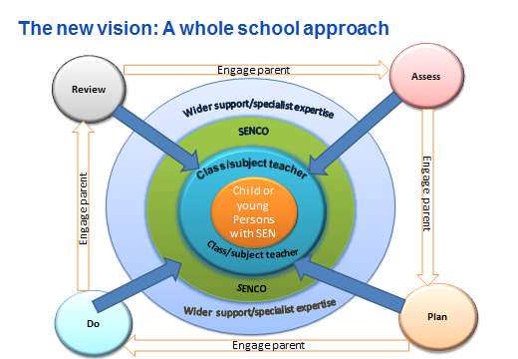

At Furzefield School every teacher is a teacher of every pupil, including those with SEND.

- In order to meet the needs of all our children, Furzefield School believes in High Quality Teaching.
- The role of the class teacher is to provide differentiated expectations for all pupils and good quality personalised teaching. This is the first step in responding to pupils who may have SEND.
- Teachers are responsible and accountable for the progress and development of the pupils in their class, including where pupils access support from teaching assistants or specialist staff.
- Pupils’ progress and outcomes are monitored through pupil tracking system and half termly pupil progress meetings
- Termly meetings between class teachers and the Inclusion Manager are held to assess any SEND needs that may arise during the term.
- Additional intervention and support is not intended to compensate for a lack of good quality teaching.
- Regular INSET and training is offered to develop teachers’ understanding and repertoire of strategies to identify and support vulnerable pupils and their knowledge of the most frequently encountered SEND areas.

How does Furzefield School decide whether to make special educational provision?

The class teacher and Inclusion Manager meet to consider all of the information gathered from within the school about the pupil’s progress based on their age and starting points and against national data and expectations of progress. This may include:
- accurate formative assessment
- internal staff moderation of progress
- provision management outcomes and any specific assessments
Where pupils are identified as having a higher level of need, we work in partnership with other specialist professionals and agencies to assess and gain advice e.g from Educational Psychologists, Physical and Sensory Support, and Specialist Teachers for Inclusive Practice.

How is the decision made to place pupils on the register?

We follow the cycle of ASSESS, PLAN, DO, REVIEW in order to offer our children the maximum opportunities in school.

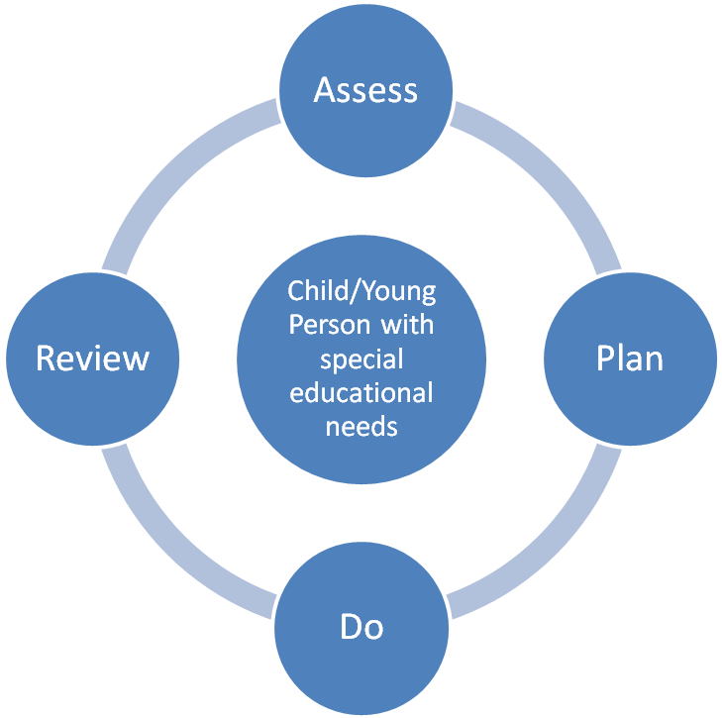

Assess: “In identifying a child as needing SEN support the class or subject teacher, working with the SENCO, should carry out a clear analysis of the pupil’s needs” (6.45 COP)
We will ensure that we regularly assess all pupils’ needs so that each child’s progress and development is carefully tracked compared also to their peers and national expectations. We will listen to the views and experience of parents/carers and the pupil. In some cases we will draw on the assessments and guidance from other education professionals e.g. EPs, PSS and from health and social services where appropriate.

Plan: “Where it is decided to provide a pupil with SEN support, the parents must be formally notified, although parents should have already been involved in forming the assessment of needs as outlined above. The teacher and the SENCO should agree in consultation with the parent and the pupil the adjustments, interventions and support to be put in place, as well as the expected impact on progress, development or behaviour, along with a clear date for review” (6.48 COP)
Where SEND Support is required, the teacher and Inclusion Manager with the parent/carer will put together a plan outlining the interventions and support which will be put in place for the pupil as well as the expected impact on progress and outcomes, including a date when this will be reviewed. Targets for the pupil will be shared with her/him using child friendly language. All staff who work with the pupil will be made aware of the plan. Parents will be asked to share in the monitoring of progress through any home learning.

Do: “The class or subject teacher should remain responsible for working with the child on a daily basis. Where the interventions involve group or one-to-one teaching away from the main class or subject teacher, they should still retain responsibility for the pupil. They should work closely with any teaching assistants or specialist staff involved, to plan and assess the impact of support and interventions and how they can be linked to classroom teaching. The SENCO should support the class or subject teacher in the further assessment of the child’s particular strengths and weaknesses, in problem solving and advising on the effective implementation of support” (6.52 COP)
The class teacher is responsible for working with the pupil on a daily basis. She/he will also liaise closely with TAs or specialist staff who provide support set out in the plan and monitor the progress being made. The Inclusion Manager will provide support, guidance and advice for the teacher.

Review: “The effectiveness of the support and interventions and their impact on the pupil’s progress should be reviewed in line with the agreed date” (6.53 COP)
The plan, including the impact of the support and interventions will be reviewed three times a year by the teacher, Inclusion Manager, parent/carer and the pupil. This will inform the planning of next steps for a further period or where successful, the removal of the pupil from SEND Support. For pupils with an EHCP, the LA must review the plan at least annually with parent/carer and pupil involvement.

We are guided in this process by the new Surrey Profiles of Need Graduated Response document.

How are parents, families, and children involved in this process?

Parents/carers are involved in meeting with the class teacher termly through parent’s consultation meetings, to set objectives and review the progress made by their child. The Inclusion Manager can be available to meet with them then, or in a separate meeting. Where possible, the pupil will also be involved (depending on age and stage of development) in the process and outcomes/targets will be written in child friendly language. We view this as a time where the partnership between home and school can be fully utilised.

SEND Provision

What does Additional Support mean?

As stated earlier, Furzefield School believes in High Quality Teaching and as such, we aim to move away from individual reliance on a Teaching Assistant.
See below an extract from P30 of SEN and Disability – A guide for parents and carers August 2014
SEN support can take many forms. This could include:
- a special learning programme for your child
- extra help from a teacher or a learning support assistant
- making or changing materials and equipment
- working with your child in a small group
- observing your child in class or at break and keeping records
- helping your child to take part in the class activities
- making sure that your child has understood things by encouraging them to ask questions and to try something they find difficult
- helping other children to work with your child, or play with them at break time
- supporting your child with physical or personal care difficulties, such as eating, getting around school safely, toileting or dressing

Specialist Provision

Furzefield Specialist Centre (The Ocean Centre) provides additional provision for 14 pupils from Reception through to Year 6 with Learning and Additional Needs (LAN). Pupils admitted to the Specialist Centre are allocated through the LA SEND Admissions and all Centre pupils have an EHCP. The children receive core learning in the mornings with specialist support from the Centre, then benefit from attending mainstream classes in the afternoons. This practice facilitates regular social interaction with mainstream peers and helps them to successfully achieve their educational outcomes. In addition to learning needs, children may have conditions including autism, speech and language needs, medical or physical needs. The Centre has a Speech and Language Therapist who works one day a week and a Speech and Language Therapy Assistant who works two days a week. Staff liaise with a range of different services. Through the additional support available at the specialist centre, children gain strategies to manage increasing independence in their learning and development. The majority travel to the school by taxi, as many come from outside the school’s immediate catchment area.

Managing the needs of Pupils on the SEN Register

Each child at Furzefield School is unique and as such requires a curriculum to reflect their needs. When a child has identified SEND, a programme will be made to meet their need. Each teacher is responsible for monitoring and evaluating their progress following the Assess, Plan, Do, Review cycle. Costed provision maps are created to demonstrate how staff and resources are being deployed.
Half termly intervention groups may be offered. There is a Whole School Provision Map, which identifies differentiated waves of intervention available for staff to draw from (See website). Where appropriate progress has not been made after interventions have been put in place, specialist support may be offered and formal assessments will begin to be put in place. For a small number of pupils, this may ultimately lead to an EHCP being considered. Parents/carers and pupils are involved as much as possible during these processes.
The Inclusion Manager, in consultation with the class teachers, reviews the SEN Register on a termly basis, and any changes are made as a result of these discussions. If necessary, changes can be made as required during the term. Relevant, appropriate progress, or lack of, will need to be evidenced before any decisions are made.

Requesting an Education, Health and Care Plan

Where, despite having taken relevant and purposeful action to identify, assess and meet the special educational needs of the child, the child has not made expected progress, we will consider requesting an Education, Health and Care Plan (EHCP). The local authority must determine whether an EHCP is necessary. They must make a decision and communicate the decision to the child’s parent or to the young person within 6 weeks of receiving the request. The local authority does not have to consider whether an EHCP is necessary where it has already undertaken an EHCP for the child or young person during the previous six months, although the local authority may choose to do so if it thinks it is appropriate. In considering whether an EHCP is necessary, the local authority should consider whether there is evidence that despite the school having taken relevant and purposeful action to identify, assess and meet the special educational needs of the child, the child has not made expected progress. To inform their decision the local authority will need to take into account a wide range of evidence, and should pay particular attention to:

• Evidence of the child’s academic attainment (or developmental milestones in younger children) and rate of progress
• Information about the nature, extent and context of the child’s SEND
• Evidence of the action already being taken by school to meet the child or young person’s SEND
• Evidence that where progress has been made, it has only been as the result of much additional intervention and support over and above that which is usually provided
• Evidence of the child’s physical, emotional and social development and health needs, drawing on relevant evidence from clinicians and other health professionals and what has been done to meet these by other agencies.

Supporting parents/carers

At Furzefield School, we recognise the importance of working closely with parents/carers. Our work has been recognised through the Leading Parent Partnership Award which we have held since 2013. We are able to provide parents/carers with support and signpost to places where they can find information. This includes:
- The SEND Information Report, on our website
- Surrey’s Local Offer, which includes other agencies who provide a service
- Our Home School Link Worker, Mrs L Hopkins
- Our Admissions Officer, Mrs G Jones
- Transition arrangements between classes, key stages, and other schools.
- Relevant local support groups, courses and support services.

Supporting pupils at school with medical conditions

Please refer to the DfE guidance April 2014.
Furzefield School recognises that pupils with medical conditions should be properly supported so that they have full access to education, including school trips and physical education. Pupils at school with medical conditions e.g. individual healthcare plans, have their notes kept confidentially whilst being accessible to those that need to share the information. Wheelchair access, electronically opening doors and stair lifts and accessible changing and toilet facilities have been established around the building. Regular training for staff is undertaken from appropriate professionals. Some children with medical conditions may be disabled and where this is the case the school will comply with its duties under the Equality Act 2010 (page 5 of the guidance). For further information, please see our Accessibility Plan.
Some children may also have special educational needs and disabilities (SEND) and may have an EHCP which brings together health and social care needs, as well as their special educational provision. For children with SEND, this guidance should be read in conjunction with the SEND Code of Practice (page 6 of the guidance)

Monitoring and evaluation of SEN Provision

We regularly monitor and evaluate the quality of SEND provision, which is then used to inform future developments and improvements.
Some of the ways we do this is through:
- Working with the SEND governor, who liaises through Full Governing Body meetings
- Monitoring & reviewing SEND funding
- School Development Priorities
- Engaging in external audits by Surrey e.g. SEN Monitoring visits by Strictly Education 4S and OFSTED inspections
- Developing best practice e.g. moderation of pupil progress through SENCO networks and local partnerships
- Monitoring the quality of teaching and learning

Training and development

All staff regularly attend SEND update training, either as whole staff or as an individual. Training is offered as a response to an area of need, either as identified in the School Development Plan, by the Inclusion Manager or at individual’s request. Recent in–house INSET and training delivered by external specialists for staff include: Linden Bridge Outreach Autism Awareness training, sensory processing difficulties, multi-sensory approaches to learning, developing vocabulary through a word-web approach, Clicker 7, Speech and Language, Positive Touch, Behaviour Clinic, Understanding Attachment, Becoming a Trauma-Informed School, Emotion Coaching, Key Adult Programme, Makaton, Behaviour for Learning – Encouraging Resilience, ELKLAN 3-5 years. Where individuals attend training, they are requested to share good practice with colleagues. The Inclusion Manager leads training for new staff in school in relation to SEND policy and school practice. The Inclusion Manager regularly attends SENCO networks and Surrey SEND conferences. The school also has membership of NASEN professional body.

Appendices:
This policy has been written in–line with SEND 14 documentation.

