

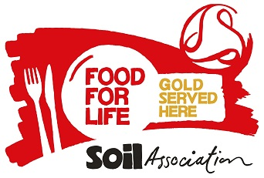

We never use fish on the Marine Conservation Society ‘fish to avoid’ list.



All of our meat, poultry, cheese and milk is Red Tractor Farm Assured or Organic.

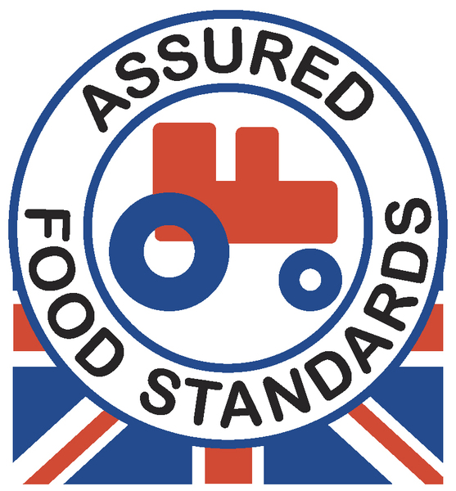 

* **We offer unlimited bread & vegetables to our customers.**
* **All our desserts are suitable for Vegetarians.**
* **Fresh fruit & yoghurts are available as an alternative**

**to the advertised dessert.**

|  |  |  |  |  |  |  |
| --- | --- | --- | --- | --- | --- | --- |
| ***School*** | | **Autumn Winter 2018-19** | | | **Week 1** | |
| **Monday** | **Tuesday** | | **Wednesday** | **Thursday** | | **Friday** |
| veglogo Southern Style Quorn Burger  in a High Fibre Bun with Jacket Wedges | Homemade  Ham & Cheese  Pizza | | Roast British Chicken with Sage & Onion Stuffing, Roast Potatoes & Gravy | Organic Pork Meatballs  served with  BBQ Sauce & Rice | | Vinegar Infused  Tempura Pollock Fillet served with  Potato Wedges |
| veglogo Veggie Bean Taco with  Vegetable Couscous | veglogo Sweet Potato Dahl served with Rice | | G:\SF Comm SW Reg Cat\Sam Walker\My Pics\veglogo.gif Quorn Fillet with Sage & Onion Stuffing, Roast Potatoes & Gravy | veglogo Ricotta & Spinach Cannelloni  in a Tomato Sauce  with a Hunk of Bread | | G:\SF Comm SW Reg Cat\Sam Walker\My Pics\veglogo.gif Carrot & Cream Cheese Whirl  served with  Potato Wedges |
| Jacket Potato  With  Quorn Sausage & Baked Beans | Chicken Fajita | | Hot Chicken Mayo and Stuffing Baguette | Pasta Pot with meatballs & tomato and basil sauce | | Sweetcorn Chowder with Homemade Croutons |
| Sweetcorn  Sliced Beetroot | Winter Salad  Garden Peas | | Diced Carrot & Swede  Winter Greens | Sweetcorn  Broccoli | | Baked Beans  Garden Peas |
| Marmalade Cake  with Custard | Fruit Yoghurt Selection | | Fresh Fruit Platter | Banana Cake | | Apple Flapjack |