

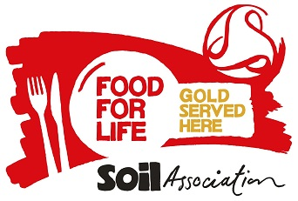

We never use fish on the Marine Conservation Society ‘fish to avoid’ list.



All of our meat, poultry, cheese and milk is Red Tractor Farm Assured or Organic.

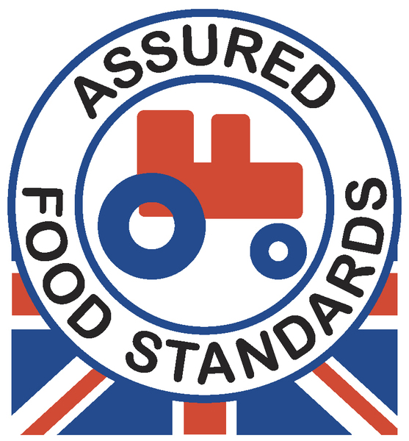 

* **We offer unlimited bread & vegetables to our customers.**
* **All our desserts are suitable for Vegetarians.**
* **Fresh fruit & yoghurts are available as an alternative**

**to the advertised dessert.**

|  |  |  |  |  |  |  |
| --- | --- | --- | --- | --- | --- | --- |
| ***School*** | | **Autumn Winter 2018-19** | | | **Week 2** | |
| **Monday** | **Tuesday** | | **Wednesday** | **Thursday** | | **Friday** |
| veglogo Quorn Lattice Slice served with  Mids Potatoes | Great British Organic Pork Sausages  with Mashed Potato  & Gravy | | Roast British Pork served with Apple Sauce,  Roast Potatoes & Gravy | Organic Beef  & Pasta Bolognese | | Wholemeal Crumb  Salmon Fillet  served with  Oven Chips |
| veglogo Tagliatelle Neapolitan | G:\SF Comm SW Reg Cat\Sam Walker\My Pics\veglogo.gif Vegetable Biryani | | veglogo Roasted Vegetable  & Cream Cheese Tart  served with  Roast Potatoes | veglogo Quorn Pasta Pesto | | veglogo Vegan Style  Chicken Nuggets  served with  Oven Chips |
| Tuna Melt Panini | Pasta Pot with Sausage in a Arrabiata Sauce | | Warm Baguette Filled with Pork and Apple Sauce | Pepperoni and Cheese Pizza | | Beef Burrito |
| Sliced Carrots  Garden Peas | Sweetcorn  Garden Peas | | Winter Greens  Cauliflower | Broccoli Florets  Baton Carrots | | Sweetcorn  Baked Beans |
| Ginger Sponge | Cheese & Biscuits  with Fresh Fruit | | Fresh Fruit Platter  served with  Crème Fraîche | Oaty Apple Muffin | | Chocolate Sponge  with Chocolate Sauce |