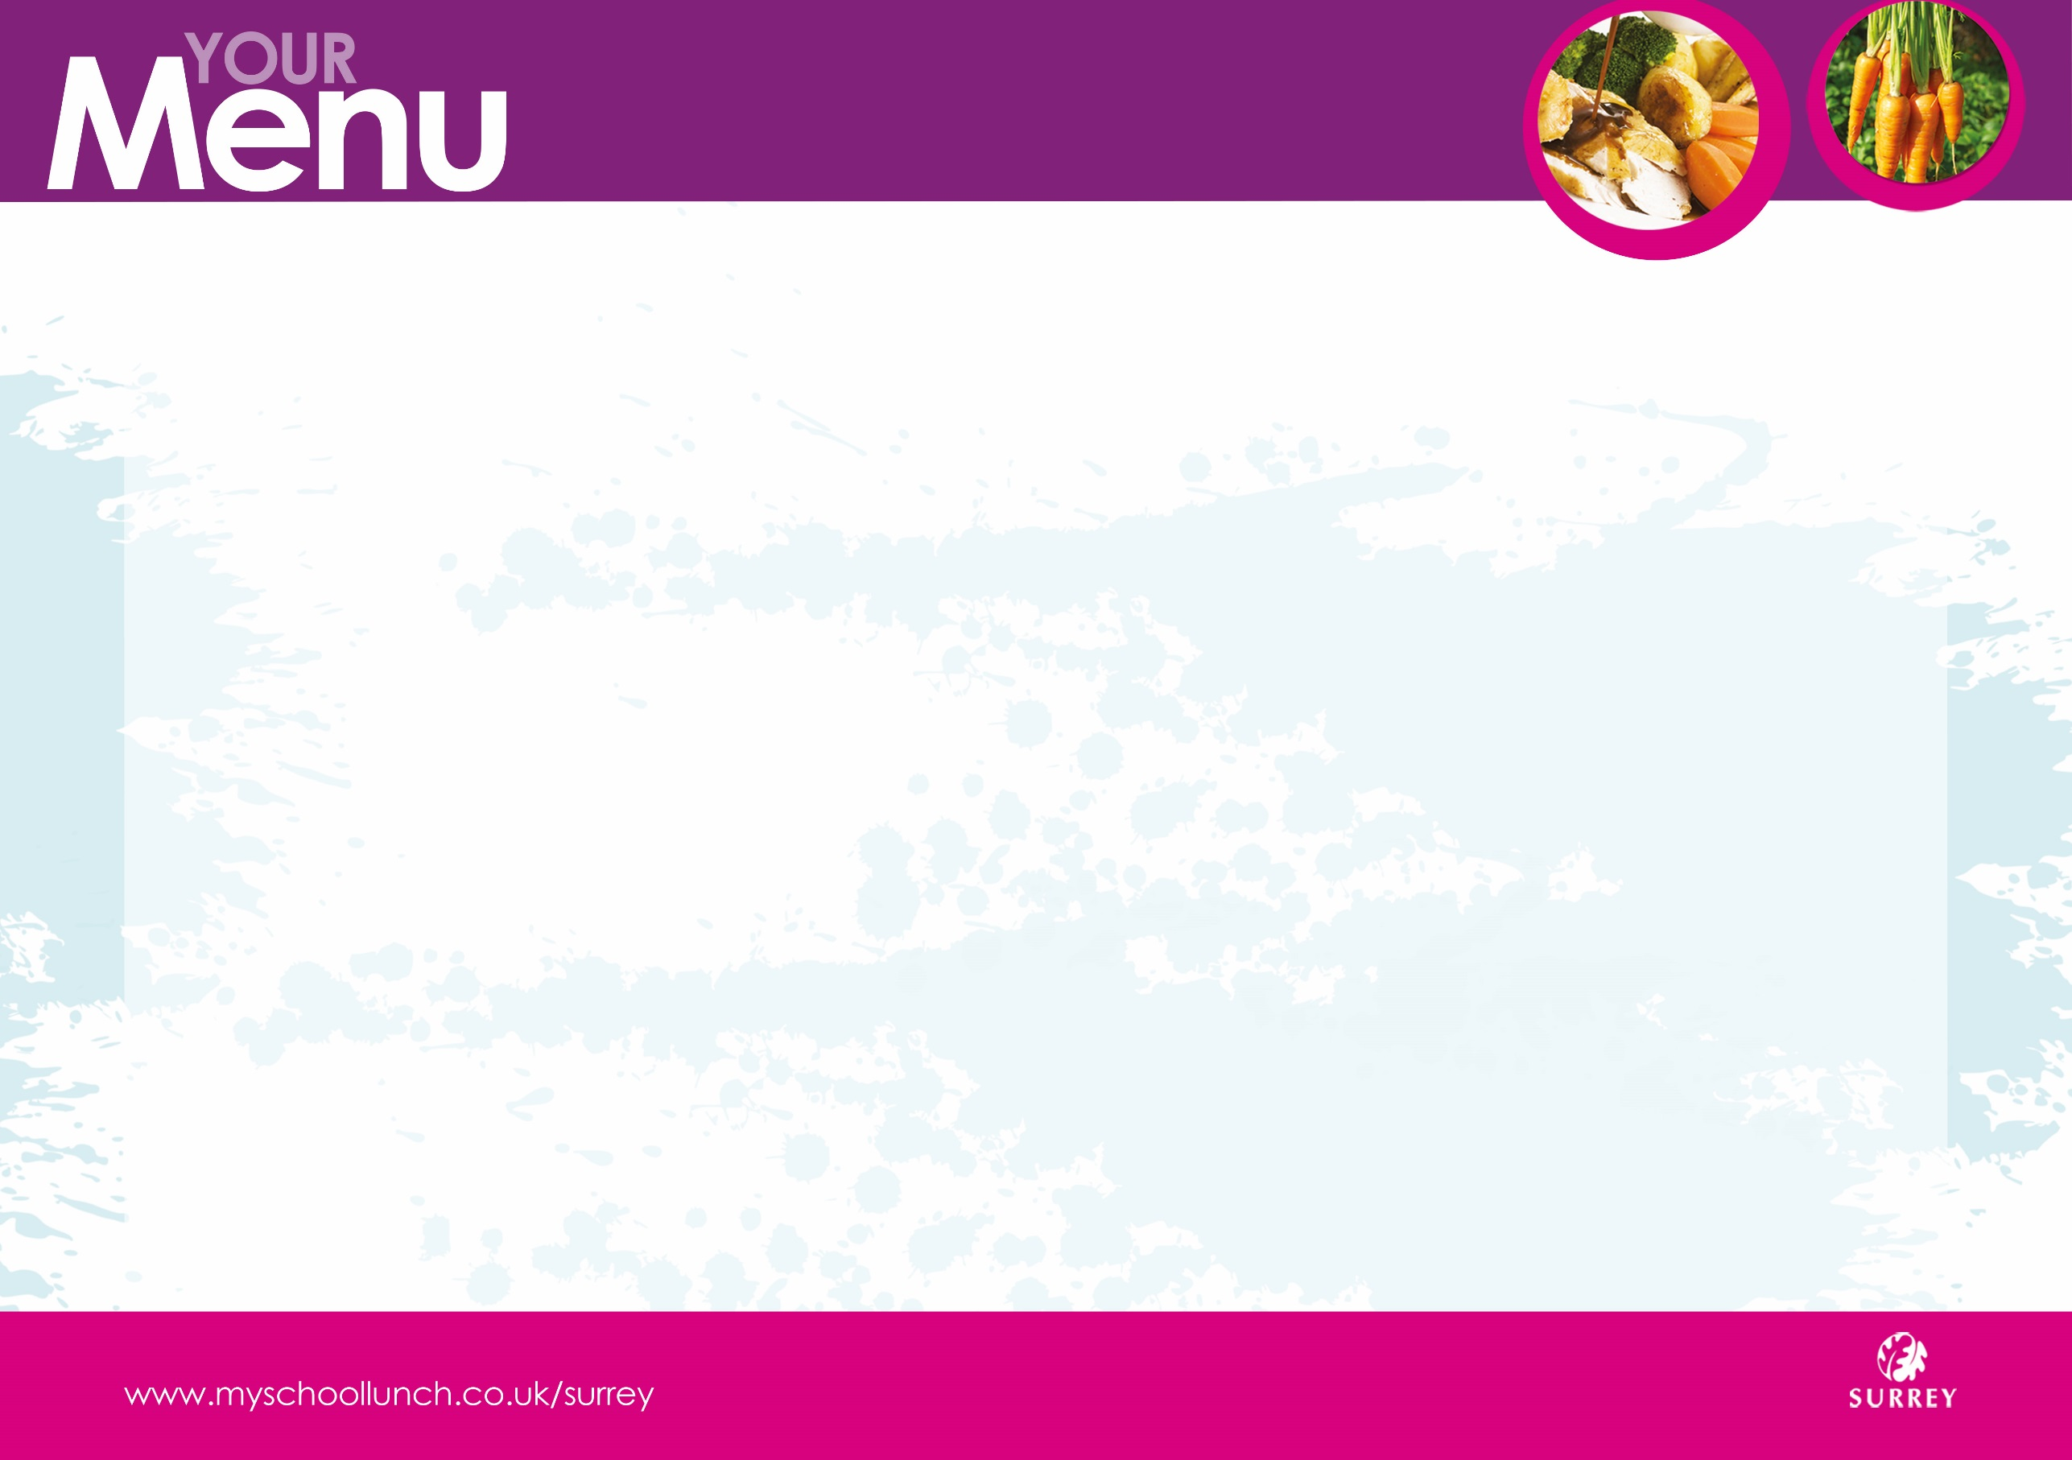

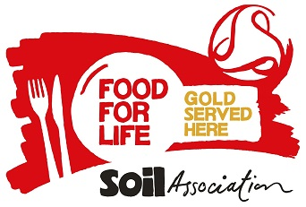

We never use fish on the Marine Conservation Society ‘fish to avoid’ list.



All of our meat, poultry, cheese and milk is Red Tractor Farm Assured or Organic.

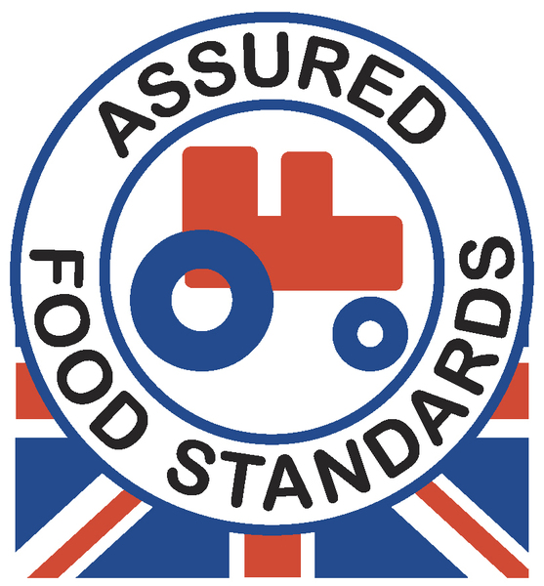 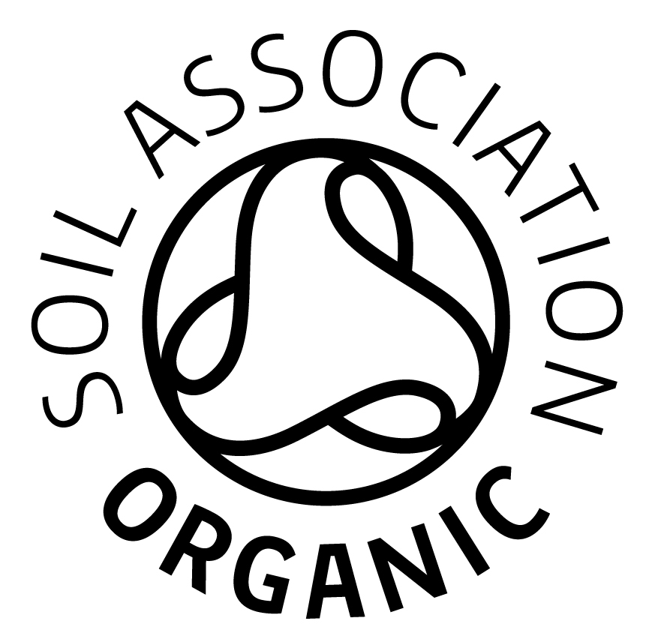

* **We offer unlimited bread & vegetables to our customers.**
* **All our desserts are suitable for Vegetarians.**
* **Fresh fruit & yoghurts are available as an alternative**

**to the advertised dessert.**

|  |  |  |  |  |  |  |
| --- | --- | --- | --- | --- | --- | --- |
| ***School*** | | **Autumn Winter 2018-19** | | | **Week 3** | |
| **Monday** | **Tuesday** | | **Wednesday** | **Thursday** | | **Friday** |
| veglogo Homemade Cheese & Tomato Pizza | Organic Minced Beef Pie topped with Golden Puff Pastry & served with Mashed Potato  & Gravy | | Roast British Gammon served with Pineapple Slice, Roast Potatoes  & Gravy | Organic Beef Burger served in a High Fibre Bun with Tomato Sauce  & Butternut Squash | | Pollock Fish Fingers  served with  Country Style Potatoes |
| veglogo Jacket Potato  filled with  Boston Beans | G:\SF Comm SW Reg Cat\Sam Walker\My Pics\veglogo.gif Quorn & Butternut Squash Curry  served with Rice | | G:\SF Comm SW Reg Cat\Sam Walker\My Pics\veglogo.gifCauliflower Cheese  served with  Roast Potatoes | veglogo Veggie Burger served in a High Fibre Bun with Tomato Sauce  & Butternut Squash | | G:\SF Comm SW Reg Cat\Sam Walker\My Pics\veglogo.gif Quorn Sausage Roll  served with  Country Style Potatoes |
| Fish Finger Wrap | Chicken and Pasta Soup with crusty bread | | Jacket Potato with Sausage and Beans | Chicken Noodle Pot | | Meatball Panini |
| Winter Salad  Garden Peas | Green Cabbage  Sweetcorn | | Broccoli Florets  Carrot Batons | Sweetcorn  Coleslaw | | Crushed Peas  Baked Beans |
| Iced Sponge | Fruit Yoghurt Selection | | Jelly served with Fresh Fruit & Crème Fraîche | Apple & Cinnamon Cobbler  served with Custard | | Chocolate Cookie served with a  Glass of Organic Milk |